**Section 21 Using Angular Modules and Optimizing Apps**

**Section 21: Lecture 267//Module Introduction**

1. This section is about how to use modules and in general how you can optimize your angular application.
2. Modules play an important role in optimizing an application.
3. We will learn how we can increase the performance of the app and how we can decrease the file size and restructure your code in an easier way.

**Section 21: Lecture 268//The Idea behind Modules**

1. 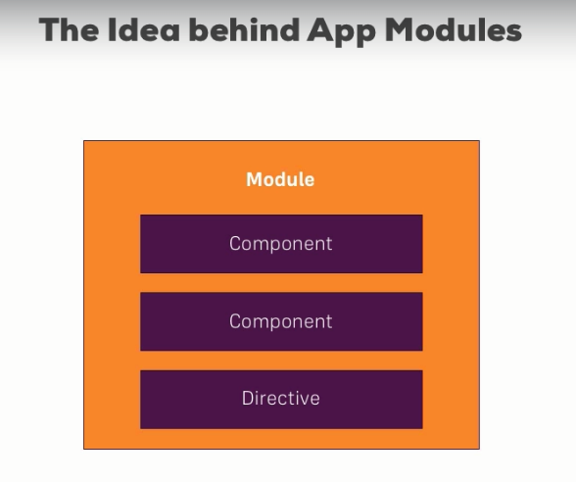

**Section 21: Lecture 269//Understanding the App Module**